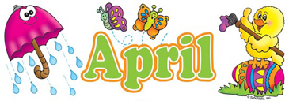

Happy April! During the month of March, we celebrated Dr. Seuss’ birthday, talked about the weather, tried to catch a leprechaun for St. Patrick’s Day, and learned all about our new season Spring. In April we will also be welcoming a new friend, Lizzie!
April Themes:
March 29th- April 2nd: Easter and letter M
April 5th-9th: Transportation and letter N
April 12th-16th: Dinosaurs and letter O
April 19th-23rd: Earth Week and letter P
Important Dates:.
April 1st: Easter Party
April 2nd: CLOSED for Good Friday
April 6th: Happy 4th Birthday Iain!

Star Of The Week:
April 5th- 9th: Ray
April 19th- 23rd: Robbie
Preschool Reminders:
- We are now using the back door for pick up/drop off- please do not let your child open the door
- With the nice weather coming please send in a light jacket
- Please send in a healthy snack for each meal (3) along with water in a water bottle

Preschools Tips:
- We are working hard practicing name and number recognition in Preschool, it’s helpful to practice at home too
- We are working very hard on being independent, please pack containers your child can open/close on their own, along with practicing putting on their own shoes/jackets at home

As always if you have any questions please call us during nap time
Miss. Kayla and Miss. Paige

