🌼🐣🐰April Newsletter 2020 🐰🐣🌼

Hi everyone! Miss. Nina and Miss. Gabby miss your babies very much! We have been thinking about them and hoping they are loving this extra time at home with you guys! We would love to say Happy Birthday to Ansley! We hope she has a great day!

Here are some great projects for you to try with your babies!

- This project can be as simple as taking an old egg carton and finger paint! The babies love to finger paint! This would also count as a sensory project because they are touching a new texture: the cardboard with paint on their fingers!
(Note: you do not have to make flowers! This is just an example of the egg carton and paint project idea!😊)

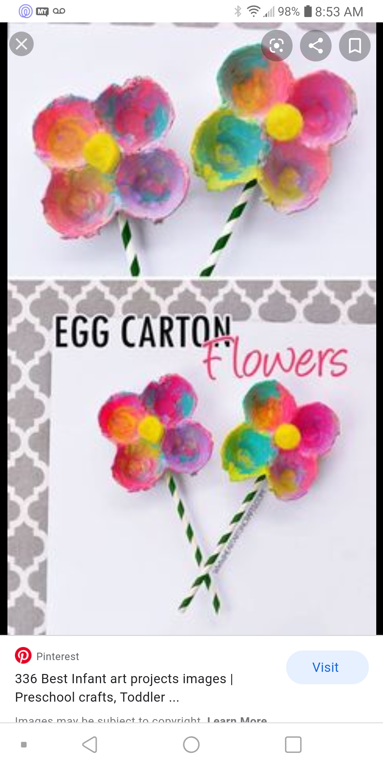
- This project is another painting project! We do this one every year with the babies. Miss. Nina and Miss Gabby put painters tape( or any tape) on a piece of white paper. We make a design or just random. Then we let the babies free paint as many colors as they would like. We tape the paper down to the table so they do not grab it. After they are done we let it dry. Then once the paper dries we peel off the tape and cut it into an egg shape!😊

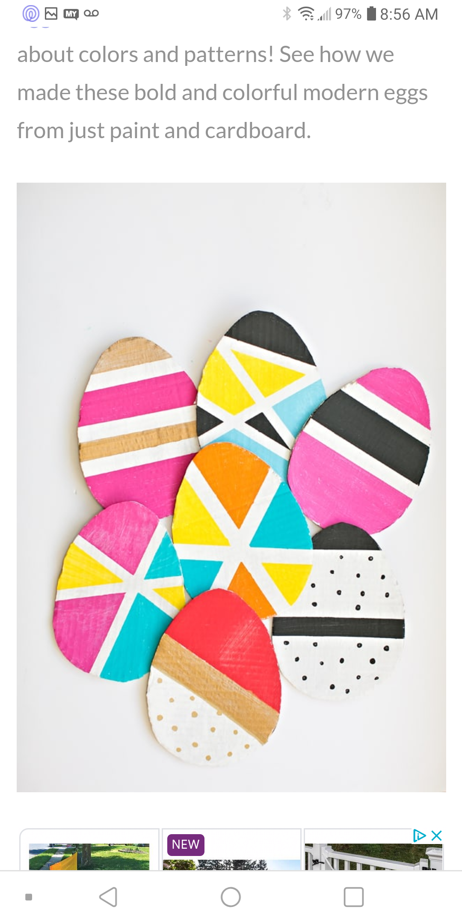
- This one is fun and simple! Take the babies hand and paint it white. Stamp it onto any color paper. Let it dry. Then draw a bunny face! (Or a silly face!😜)

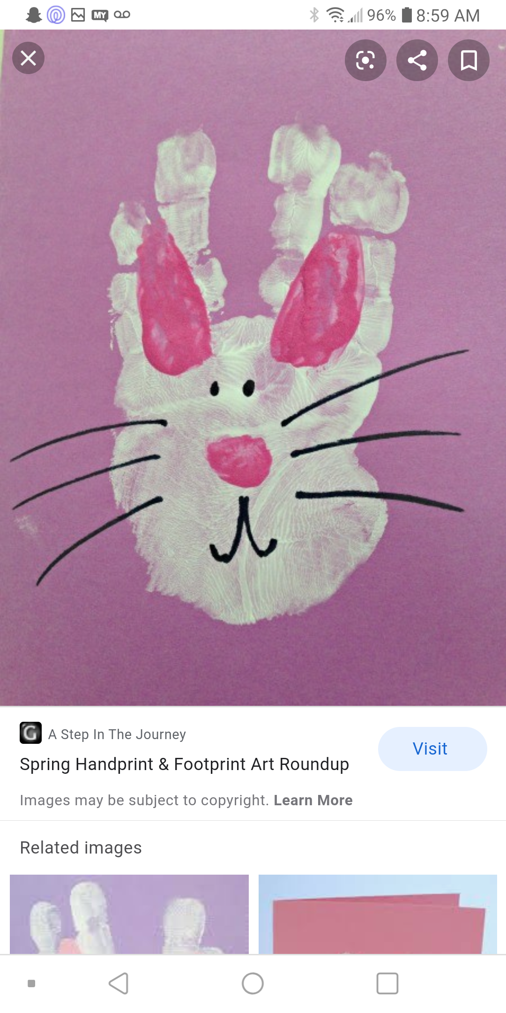

🐣Activity for Easter 🐣
- Have you and your child go outside and pick acorns or even rocks! Get about 6 or so.
- Help your child put them in plastic eggs(the ones you use for Easter egg hunts!)
- Then tape or glue them shut.
- Let your child shake shake shake them!

🐰🐣 Song for Easter 🐣 🐰
Here Comes Peter Cottontail

Here comes Peter Cottontail
Hoppin' down the bunny trail
Hippity hoppin', Easter's on its way
Bringin' every girl and boy
Baskets full of Easter joy
Things to make your Easter bright and gay
He's got jelly beans for Tommy
Colored eggs for sister Sue
There's an orchid for your mommy
And an Easter bonnet too
Oh! here comes Peter Cottontail
Hoppin' down the bunny trail
Hippity hoppity, happy Easter Day
Here comes Peter Cottontail
Hoppin' down the bunny trail
Hippity hoppin', Easter's on its way
Try to do the things you should
Maybe if you're extra good
He'll roll lots of Easter eggs your way

We hope you have a great holiday and facetime with your families! Please stay happy and healthy! We cannot wait to see you and your babies in a few weeks! Happy Easter! 🐰

-Miss. Gabby and Miss. Nina

