Hello Infant Families,

I cannot believe October is already here and Halloween is right around the corner! Madison will be 1 years old this month, Happy Birthday Madison! There is so many fun things planned for this month. The themes this month will be Fall, Spiders, Pumpkins, and Halloween. I cannot wait to see how all of our projects will come out!

Important Dates:
Monday 10/11 Center Closed
Thursday 10/21 Picture Day
Spooky Family Night TBD

Reminders:
- Please bring in a family photo so we can complete our family tree.
- Please try and pack a range of items that can be layered, such as a short-sleeved onesie/shirt with a long-sleeved light sweater.
- Please label everything that you bring in for your child. Crib sheets, bottles, cups, lunch bags, and snacks that need to be refrigerated. This makes it easier so there is no confusion with any belongings.
- You can bring extra food/snacks in but I ask for you to leave them in your child’s bag or lunchbox.
- For wipes I ask for 4 packs for full time, and 3 pack for part time a month. I will let you know when diapering supplies are running low.

If you have any questions or concerns please don’t hesitate to reach out to us. We
will happily address any questions or concerns that you may have.

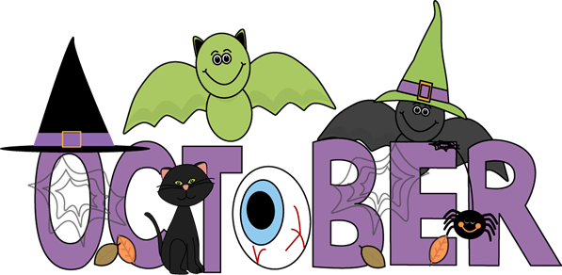
~ Miss Haley & Miss Taylor ~

