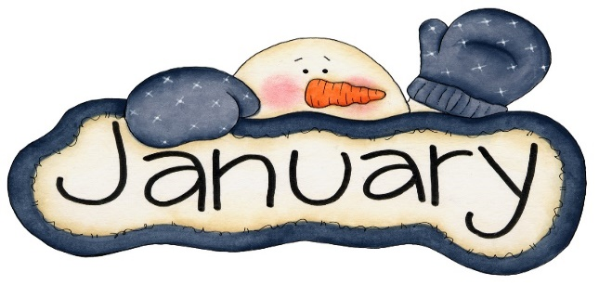
Welcome back from our winter vacation!
We hope everyone had a great holiday and we wish you a happy, healthy new year!
As we settle into another month,
We would like to wish Miss Ashley the best on her upcoming due date of January 8th!
She looks forward to everyone meeting her baby girl when she returns in April!

Upcoming themes: New Years, Hats & Gloves, Arctic Animals, Cold Sensory Play

A couple reminders:
It’s Martin Luther King Jr.’s birthday on January 18th.
We will be open but please let us know if your child will not be attending that day. This helps us ensure appropriate staffing.

The weather is getting chilly inside and outside. Please make sure to have weather-appropriate clothing packed: long sleeved onesies, a thin sweater, socks.

Everything must be labeled: frozen bags of breast milk, bottles, caps, blankets, lunch bags and anything else that comes into the room so we can make sure these items return to their owner.

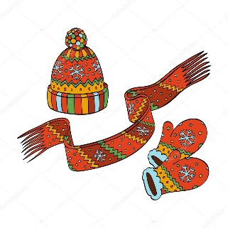
Thank you, Infant families, for being so patient with the new COVID policy of one family per child in the entrance at a time! With weather becoming colder, we have decided to start sending home “Daily Sheets” every Friday for the following week. We ask that you fill these out prior to drop off to keep the lines moving, but to also allow for more face-to-face communication rather than writing. We will still keep these at the table just in case one is forgotten at home!

Thank you for everything you do to keep our program running smoothly!
If you have any questions please call or e-mail the center!

Love,
Miss Ashley, Miss Merry, Miss Angela and Miss Tonie

