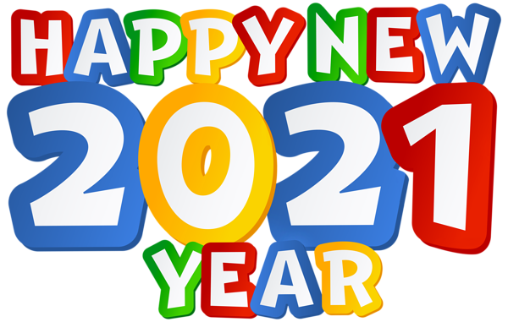

January Pre-K News
I hope everyone had a wonderful holiday break! We are excited to be back! This month our themes will be Happy New Year, Snow much fun, Polar Animals, and Hibernation. We will learn the letters Nn, Oo, Pp, and Qq.
Birthdays:
Brady- Jan. 7th
Martin Luther King Jr.- Jan. 18th
Please remember to have appropriate clothes and extra masks in your child’s bags! We try to go outside every day.

