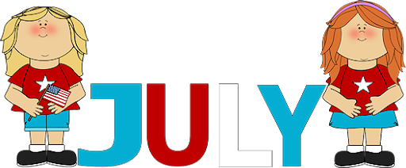
Welcome back to Pre-k! There are a lot of changes since we were last at ORCCC and will take some time to adjust and get into a new routine. If you have any questions please do not hesitate to ask!
Ms. Melissa
Reminders:
- Please label EVERYTHING *INCLUDING MASKS*
- Please make sure all belongs fit inside a bag that fits inside their cubby
- Please provide enough food and snacks for the entire day we are not providing snacks or pizza lunch
- At this time no parents are allowed inside the building except infant parents
- Drop off and pick up will be happening at the back of the building
- We will be encouraging children to wear masks
Happy Birthday:
Jacob: July 28th

Pre-k July Themes:
July 6th- July 10th: Party In The USA
July 13th- July 17th: Christmas In July
July 20th- July 24th: Pirates and Princesses
July 27th- July 31st: Camp Out

Happy Birthday:
Miss. Kayla: July 2nd
Elliot: July 7th

