Welcome to the month of March in Pre-Kindergarten! We all did a wonderful job practicing to write our names on our valentines last month! Our Pre-K friends are getting so big and doing such a nice job writing their names with an upper-case letter followed by lowercase letters. Practice, Practice, Practice!! Keep up the good work! We can’t believe how fast February flew by and that March is already here! We are ready for SPRING !
As always, Pre-kindergarten has been a very busy place and will be for the rest of the school year! March is national reading month, so we will be having a special celebration for Dr. Seuss’ Birthday and we will read some new stories! Also, we will be trying to catch that sneaky little leprechaun! We look forward to lots of fun this month!
Dear Mom and Dad,
I love to learn and grow with you!
* Please read with me every day! This is a warm and loving time when then two of us can cuddle and enjoy quality time together! Give me a chance to read to you too... I love to tell stories as I ‘read’ the pictures!
* I love to talk about what’s happening in the books that we read, point out things on the pages and ask LOTS of questions!

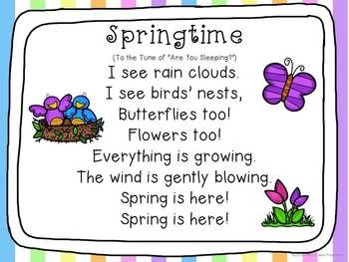
Mark your Calendars
Pizza: 5,13,19,27
Miss Meg: 19
Stony Brook – Reptiles : 12
Easter Family Night : TBD
Learning and Fun in Pre-K
3-7 : Happy Birthday Dr. Seuss
10-14: Up, Up and Away in Space
17-21: Happy St. Patrick’s Day
24-28: Welcome Spring

