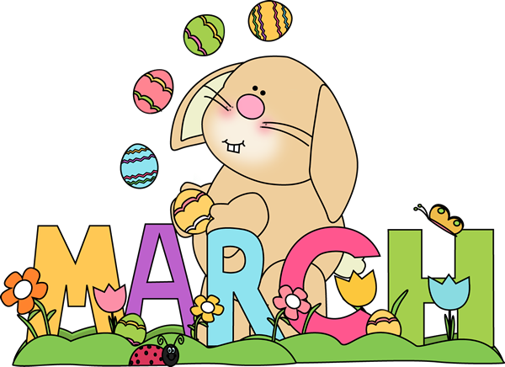
”You can find magic wherever you look. Sit back and relax, all you need is a book”
-Dr. Seuss
Important dates to remember:
Fechas importantes:

Pizza
March 5th, 13th, 19th, 27th

Easter Family Night
To be determined

Please provide $1 by Wednesday of each week
Por favor traiga dinero antes del miércoles

There are many fun things coming up in March! From Read Across America, to March Madness, to Leprechauns and Spring! Here are a few reminders to keep our classroom happy, healthy, and safe:

While we can often guess whose items belong to who, there are going to be times that your child visits another classroom this spring in preparation for their eventual graduation to the next room. To help make sure all items go (and return) please make sure everything is labeled. This includes bibs, clothing, shoes, cups, sheets, bags - anything that could possibly leave the room and have a different set of teacher eyes.

The yearling room is a classroom full of transitions. This means that we are beginning to use our hands and bodies in all different ways, from learning to self feed to experimenting with art. While we do our best to keep clothes clean, there may be times that creativity and the urge to explore will happen (as will dirt, paint, and spaghetti sauce)!

The nicer weather is coming, please go through your child’s spare clothing and make sure they have seasonally appropriate clothing. We can’t wait to go outside!

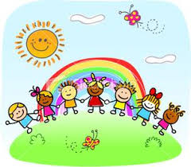
Love,
Meredith & Christine

