

**Themes**

**May 3rd – 7th**

I ❤ my mom!

**May 10th – 14th**

Caterpillars & Butterfiles

**May 17th – 21st**

Farm Animals

**May 24th – 28th**

Down by the Pond

**May 24th – 28th**

**May Dates**

**May 12th Charbel**

**May 31st Memorial Day**

**CENTER CLOSED**

**Reminders**

* As the weather gets warmer, we ask that you PLEASE apply sunscreen in the morning prior to coming to school if the forecast predicts a sunny day. We will reapply in the afternoon.
* If you have not returned your sunscreen permission slip, please do so ASAP or else we cannot apply sunscreen to your child in the afternoon even on the sunniest days.
* Please make sure that your child has a weather appropriate change of clothes in his or her bag and 2 **CLEAN MASKS** at all times.
* **Please** make sure your child has 1-2 books and an activity or coloring book each week for rest.
* THANK YOU!!

**[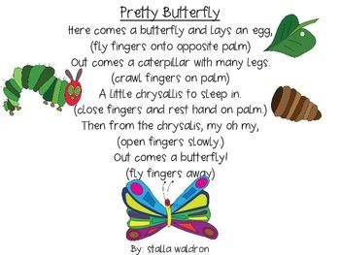](http://www.teacherspayteachers.com/Product/Pretty-Butterfly-Poem-and-Props-1156811)**

**\*\*Pre-K Graduation will take place the week of June 18th\*\***

We are still working out the details but it will just be our **Pre-K** class of 2021!!

2 guests per student will be allowed if indoors due to COVID restrictions.

More information to follow.