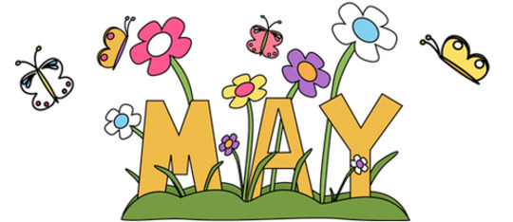
April showers bring May flowers and another month home.
- We will continue to do two weekly zooms Tuesday afternoon at 3:00 pm and Thursday morning at 11:00 am.
- We are working on a date and time for a May parade- we loved seeing everyone at the last one. At this parade we will be handing out a packet of crafts and activities you can do at home!
- Please send Liz pictures of art work for the Art Show childcare212@or-ccc.org
- Please reach out to any of us via Facebook message, phone call/text, or any way if you need anything!
- We love seeing everything you child is doing while at home, keep up posting on our Preschool Facebook group page “ORCCC Preschool”
We miss you all so much!
Kayla, Megan, Emily
May Themes:
May 4th- May 8th: flowers and planting
May 11th- May 15th: Caterpillars and Butterflies
May 18th- May 22nd : Bugs
May 25th – May 29th : Legos

Happy Belated Birthday To:
- Lydia
- Tory
- Llewyn
- Rhys

