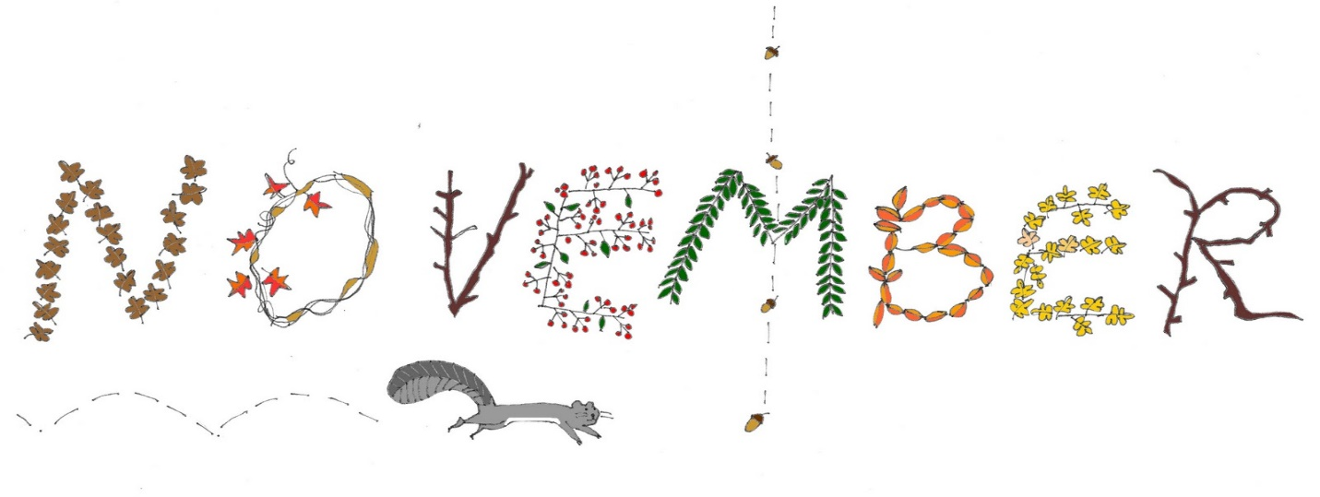
Wow, can you believe it’s already time to welcome November?! We will be talking a lot this month about all we are thankful for! We will continue working on our alphabet recognition, writing our names, counting, patterning, sorting, using teamwork and positive words, and making many projects. Please continue working on names at home. Remember a capital followed by all lowercase letters. As always if you have any questions feel free to ask Jen or Melissa anytime!
Although we are not able to have our traditional Friendship Feast with our Preschool friends we will still make all of our feast gear and have a special lunch in our classroom. Please bring in a brown paper bag by Nov. 13 please
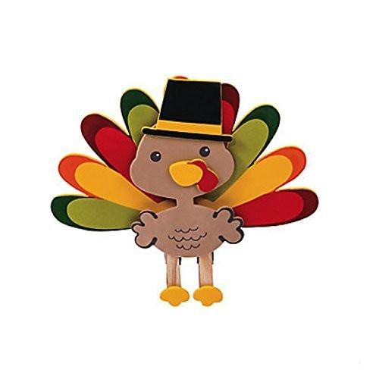

Pre- K Reminders...
~Please remember that all Pre-K students must arrive wearing a mask that fits and covers their nose and mouth. All children must also have a couple extra masks that fit properly in their bags.
~Its getting chilly and we will go outside 2x a day. Please make sure your child has a jacket daily and can put it on by themselves.
~As always please label everything.
November Themes
11/2 – 11/6 Shapes and “D”
11/9 – 11/13 Fall Harvest and “H”
11/16 – 11/20 Thanksgiving and “I”
11/23 – 11/25 Thank You God
Important Dates
11/3 HBD Connor
11/10 HBD Maeve
11/13 HBD Jace B & Welcome to Pre-K!
11/26 & 11/27 CLOSED
Happy Thanksgiving!
**FLU shots by 12/24 PLEASE**
*Reminder we are closed 12/25 – 1/4

