

**Our Redeemer Child Care Center**

**Toddler Room – Group 2**

**June 2021**

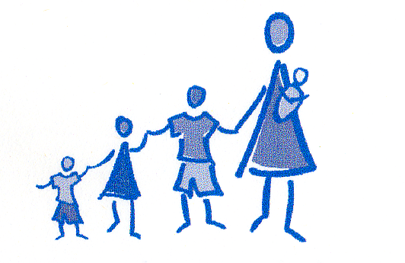

**June Songs and Fingerplays**

**In Tune with Tools “Head, Shoulders, Knees & Toes”**

Saw, hammer, tape measure, tape measure.

Saw, hammer, tape measure, tape measure.

Pliers, paintbrush, and screwdriver.

Saw, hammer, tape measure, tape measure.

**Finger Family Fingerplay**

Finger family up, (Wiggle fingers up)

Finger family down, (Wiggle fingers down)

Finger family dancing all around the town. (Wiggle fingers all around)

Dance them on your shoulders. (Wiggle fingers on shoulders)

Dance them on your head. (Wiggle fingers on head)

Dance them on your knees, (Wiggle fingers on knees)

And tuck them into bed. (Fold hands and put beside face)

**“Five Little Speckled Frogs”**

Five little speckled frogs, sat on a speckled log,

Eating the most delicious bugs. YUM, YUM!

One jumped into the pool, where it was nice and cool,

Then there were four green speckled frogs. GLUB, GLUB!

(cont. 5…4…3…2…1…no more speckled frogs)

**Weekly Themes**

Construction!

Families & Father’s Day / Our Favorite Things

Summer Program Begins / World Travelers

Pond Life

**Notes!**

* + - * The summer program begins on June 21st
      * We will be having a Rain forest and reptile show on June 8th

presented by Stony Brook

* + - * We spend a lot of time outdoors in the summer – don’t forget that sunscreen should be applied at home in the morning and we will re-apply in the afternoon.
      * Sneakers are the safest and best choice for school.

**Transition is a Journey…**

Feelings of sadness and resistance can be common as children prepare to leave a familiar setting or situation. Children need to express how they feel – and adults can help children to express themselves by talking about and acknowledging their feelings. We can also help them to gain confidence by being positive and helping them to become familiar with their new environment. Over the next couple of weeks, feel free to take a moment to visit your child’s new classroom and say hello to their new teachers. Also, don’t forget that transitions are also a time to celebrate a children’s growth! Let them know how much they have grown by pointing out new accomplishments.

*-Adapted from “Early Years are Learning Years”*

*www.naeyc.org*

*What a wonderful year we have had!* ***Our summer program begins on Monday, June 21st.****A fond farewell to all of our graduates entering the Preschool Classroom: Logan, Ciara, Charlie, Jimmy, Carl, Giana, Olivia, Marykate, and Avery. This summer, Toddler Group 2 welcomes its new class. Families, it has been such a joy to work with your children and watch them grow. And, how they have grown! Time goes by too fast, especially during these early years. Have a wonderful summer – make some memories! Sincerely, Amanda & Joan*