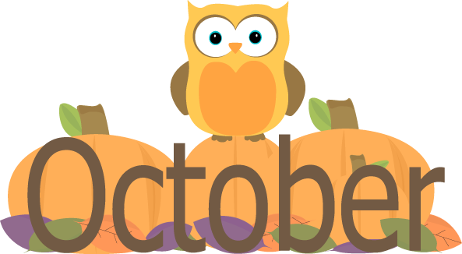
Dear Parents!
Our first month of Pre K has come and gone and we have had a blast. The children are making great strides and seem to be settling in very well. During the month of October, the children will be starting on a letter a week, working on writing their names and practicing cutting skills. Remember when practicing at home we write our names with an uppercase followed by lowercase letters. Please work on these skills with your child at home. Thank you for all your hard work with them!
Although the weather is changing, our class goes outside every day. Please be sure to send appropriate clothing for your child to go outside. Label each item of clothing your child will be wearing. Also remember that all of your child’s items need to fit inside of their cubby! Please practice putting on coats with your child, all Pre- K children are expected to put their coats on.
DATES THEMES
Pizza Oct. 8, 14, 22, 28 10/4 - 10/8 Community Helpers
Center CLOSED Oct. 11th 10/12 - 10/15 God’s Pumpkin Patch
Nature Detectives 20th 10/18 - 10/22 Monsters
Picture Day 21st 10/25 - 10/29 Halloween
Spooky Family Night TBD
HaPpY BiRtHdAy… Lyla 24th, Robbie 26th and Abby 31st
^{**Important Reminders…}
Children must come to school wearing a CLEAN mask they can put on everyday.
All Children must have 2 CLEAN unworn masks in their cubby as back up at all times.
For rest your child needs 1 crib sheet, 1 blanket and a couple books for rest every week.
They can also have one small plush rest item. NO PILLOWS

THANK YOU, Miss Melissa & Miss Jen

