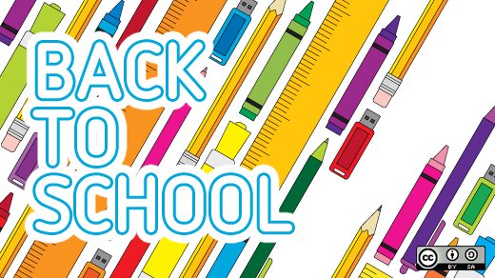

Pre-K Newsletter- September 2021
Welcome Pre-K families to a new school year which promises to be full of fun, friendships, learning, and growth! We’re excited to begin the year with a new group of pre-kindergarten friends! We had a great summer with some of our friends already and we are excited to welcome more new friends for the school year.
Our September themes will be:
Sept. 6th-Sept.10th-Welcome Back
Sept.13th-Sept.17th- All about me
Sept.20th-Sept.24th-Fall
Sept.27th-Oct.1st-Apples

Important Notes-
-Please label everything
-All belongings must fit in one bag that fits in cubby and that your child can maneuver on their own.
-Please have extra masks everyday
-Please bring in a recent family photo

Birthdays this month- Grady Sept.13th
Dates we are closed-Sept.3rd for prep and Sept.6th for Labor Day
If you have any questions, please feel free to speak to one of your Pre-K teachers. We look forward to a year full of laughter, fun, and learning!
Miss Melissa and Miss Jen

