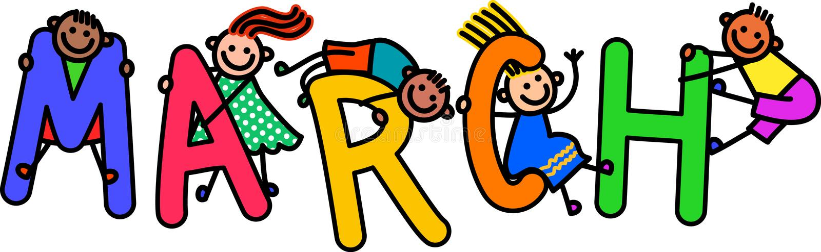
We are lucky to have our class of Preschoolers!
Important Dates
March 17th: Happy St Patrick’s Day (Wear Green!)
Chapel: March 2nd, 16th, 30th
Pizza: March 4th, 10th, 18th, 24th

Star of the Week
March 7th – March 11th: Madyson
March 21st – March 25th: Quinn
Reminders
-Please bring in snow gear when it snows (mittens, snow pants, jackets and snow boots)
-Our preschool friends are practicing tracing their names; we would love to see them practicing at home!
-Please empty art folders daily, there will be many more fun projects to come
-We are always encouraging independence in preschool, please have your child practice putting on their own masks, shoes, snow gear and opening up lunch containers and snacks

Preschool Themes
February 28th – March 4th: Dr. Suess (I)
March 7th – 11th: Pets (J)
March 14th – 18th: St Patrick’s Day (K)
March 21st - 25th: Disney (L)
March 28th – April 1st: Rainbows (M)

Thank you so much! If you have any questions, please do not hesitate to reach out during rest time!
Miss. Kayla and Miss. Paige

