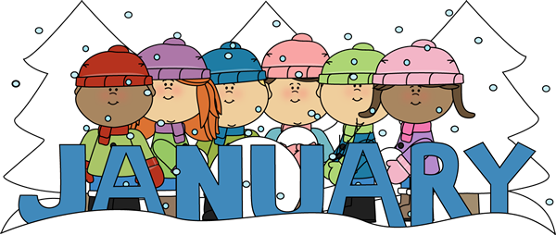
2021 already? We hope you all had a wonderful holiday and a Happy New Year! We are already half way through preschool- how crazy is that! We will be starting to learn our letters by having a new letter of the week every week. We are also not having any more home toys- our guidelines have changed.
Important Dates:
January 18th: Martin Luther King Jr Day we are OPEN but please let us know if your child will be absent for staffing
January 18th: Happy 3rd Birthday Patrick S!
January Themes:
January 4th- January 8th: Winter Animals and letter A
January 11th- January 15th: Winter and letter B
January 18th- January 22nd: Pete the Cat and letter C
January 25th- January 29th: Colors and letter D
Preschool Tips:
- Every morning your child is “signing in” – practicing writing their name- encourage them to practice at home
- Encourage your child to get dress by themselves in the morning and put on their own jackets/hats/gloves/etc
- Practice with scissors at home, whether it’s to cut out a shape or on a line or just cutting for fun (safely of course )
Star of the Week:
Drew: January 11th- January 15th
Patrick S: January 18th- January 22nd
Grady: January 25th- January 29th

We are looking forward to seeing what this new year brings for preschool!
Miss. Kayla and Miss. Paige

