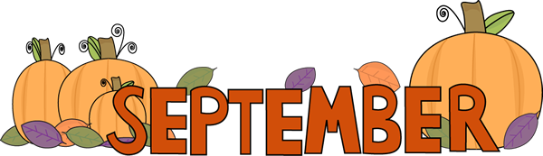

Welcome to Preschool! We are so excited to start the school year with your child. This year will be filled with lots of fun activities, making new friends, and so much more! We are also welcoming a new teacher in Preschool- Mrs. Joanne!
Coming back to school after a long time at home will be a big adjustment and we will work with both you and your child to make this change as smooth as possible.
September Themes:
September 7th- September 11th: Back To school/All About Me
September 14th- September 18th: Leaves
September 21st- September 25th: Fall
September 28th- September 2nd : The Alphabet
Reminders for drop off:
- Remember to fill out daily health screening
- Children will wash hands while you are filling out paperwork
- Masks required for child AND parents
- We love talking with you but please be courteous of other parents while dropping off
- If there is another parent dropping off before you please have your child stand with you *please do not tell them to walk in with their friend*

Important Dates:
September 7th: Closed for Labor Day
**Please send back paper “Tell us about your child” ASAP
Reminders:
- No parents allowed in the building
- We are not heating up any lunches
- We are not providing any extra snacks
- Please have your child wearing their mask when arriving to school – practice with your child how to put in on/wearing it at home
- Label EVERYTHING
- No pillows for rest time
- All items must fit inside your child’s backpack

If at any time during the year you have any questions please feel free to call during nap time (1-2:30) or during pick up.
We cannot wait for an amazing year in Preschool!
-Miss. Kayla and Mrs. Joanne

