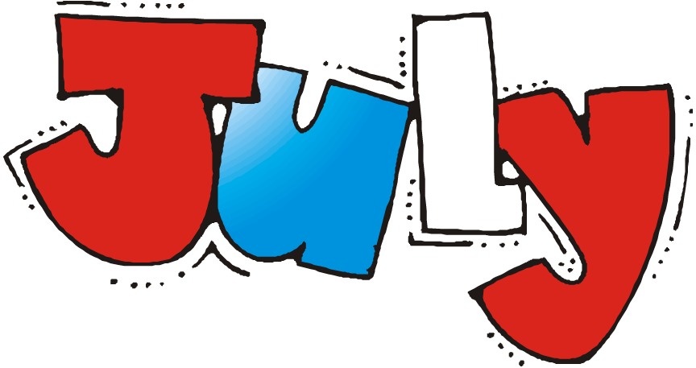
Welcome back!!! It has been a long three months, and we missed you all so much. There are a lot of changes since we were last at ORCCC and will take some time to adjust and get into a new routine. If you have any questions please do not hesitate to ask!
Miss. Kayla and Ms. Kim
Preschool July Themes:
July 6th- July 10th: Ocean
July 13th- July 17th: Camping
July 20th- July 24th: Zoo
July 27th- July 31st: Luau
Happy Birthday:
Miss. Kayla: July 2nd
Elliot: July 7th
Reminders:
- Please label EVERYTHING *INCLUDING MASKS*
- Please make sure all belongs fit inside a bag that fits inside their cubby
- Please provide enough food and snacks for the entire day we are not providing snacks or pizza lunch
- At this time no parents are allowed inside the building except infant parents
- Drop off and pick up will be happening at the back of the building
- We will be encouraging children to wear masks

