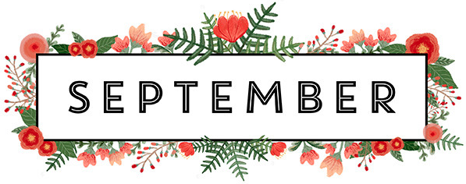
Welcome back Preschool! We hope you all had an amazing and safe summer. We are looking forward to the new school year!
Important Dates:
CLOSED: September 3rd and September 6th
Happy Birthday:
Giana: September 16th
Reminders:
-Please label all of your child’s items including masks
-Please provide enough snacks (one healthy, one crunchy) for each morning/afternoon snack and lunch
-We are encouraging independence in Preschool so please practice putting on mask, shoes and pants at home
Preschool September Themes:
August 30th - September 3rd: Crazy Week
September 6th- September 10th: All About Me
September 13th- September 17th: Farm
September 20th – September 24th: Fall
September 27th- October 1st: Colors

If you have any questions please do not hesitate to ask!
Miss. Kayla and Miss. Paige

