

**Welcome to the month of March 2022**

* **March is national reading month, so we will be having a special celebration for Dr. Seuss’ Birthday and we will read so many new stories!**
* **Don’t forget to read at home as well. It’s a warm and loving time when you can cuddle and enjoy quality time together!**
* **Pizza dates: Friday March 4th, Thursday March 10th, Friday March 18th, and Thursday March 24th**

**Learning is so much FUN!!**

**Theme for March**

* ***Dr. Seuss***
* ***Transportation***
* ***St. Patrick’s Day and***
* ***Spring***
* ***lambs***

**The Center is closed 4/2 for Good Friday**

**Class Reminders…**

*Please make sure your child has at least one healthy choice for each meal time. Fruit, veggies, cheese stick, yogurt… 3 healthy choices/day.

*Rest Time… Each week please send 1 sheet, 1 blanket all labeled.

Also remember to send in extra clothing, labeled even if you think your child has one as accidents may occur.

Thank you!

Ms. Joan and Trish

**The more that you READ, the more things you will KNOW. The more that you LEARN, the more places you’ll GO. – DR. SEUSS**

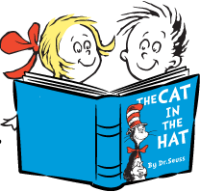

**March 2nd is Dr. Seuss’s birthday - celebrate with a story!**

What a year it has been!!! Our kids have just lived through a crazy year, learning a “new normal” and are doing a fantastic job in Toddler 2! We should be proud of them and even more proud of ourselves…together we did it and are continuing to make it through!!