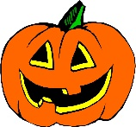TODDLER 2 NEWS LETTER FOR OCTOBER
Welcome into October! We love Halloween in the Toddler 2 room and love doing fun projects. Please look around the classroom to spot some spooky fun projects this month!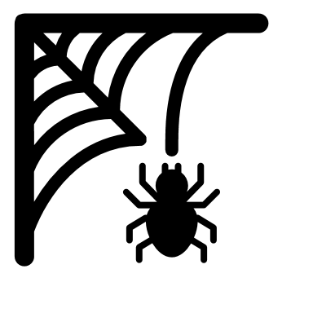
Our Themes for the month are:
Fall, Farm, Fire Safety and Halloween
Important Dates:
- Pizza: 8,14,22,28
- Nature Detective: 20th
- PICTURE DAY!: Thursday, Oct. 21th! More info to follow.
- 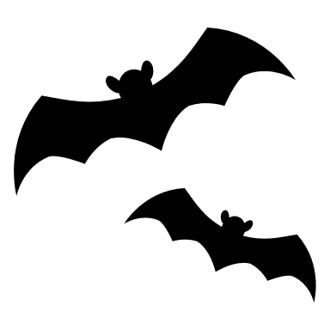SPOOKY FAMILY NIGHT!: TBD. This year we will decorate our halls and have a spooky walk for the kids. (5:30-6:30).
- CENTER CLOSED: Monday, Oct. 11th (Columbus Day)
Important Reminders:
- Please label everything! This includes anything that your children bring to school. We cannot give foods/bottles/loveys to your child at school if they are not labeled with their names on them.
- We recognize that your child might find comfort in a lovey or soft animal. We know sometimes they need that familiar object to make them feel comfortable for nap time, please only bring one and keep them in their cubbies located in the classroom.
- We will be doing lots of spooky fun things this month.
Like always, please come to us with any questions about anything! We want your children to enjoy their time here at school.
HAPPY HALLOWEEN !!!!
Joan and Trish

