|  |  |  |
| --- | --- | --- |
| [Fall Clip Art - Fall Images](https://www.google.com/url?sa=i&url=https%3A%2F%2Fwww.mycutegraphics.com%2Fgraphics%2Ffall-images.html&psig=AOvVaw0usQODkB0nKR9h-eg7qFdd&ust=1630424003302000&source=images&cd=vfe&ved=0CAYQjRxqFwoTCKChgPOW2fICFQAAAAAdAAAAABAD) |  |  |
| Welcome to Yearlings!!   I am so excited that the yearling room has opened back up for the 2021 school year and that I get to be your yearling teacher! I can’t wait to watch all of my friends learn and grow in the yearling classroom! Every month we will have “themes” to guide our learning. This month, we will focus on getting to know each other, caring for our friends and welcoming fall. We will sing songs, create art and engage in lots of fun learning activities! We are going to have so much fun laughing, learning and playing together!! |  |  |

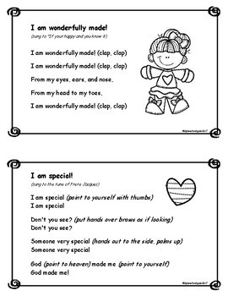

**Mark Your Calendars :**  
CLOSED **– Sept. 6th**   
**Happy Labor Day!**  
  
**Parent Orientation – TBD**   
Come chat with your yearling teacher and learn more about what we will be doing this year in the yearling classroom!   
* Parents only please, no kiddos 😊 Thank you!

**Reminders:**

* Please bring in a family photo to be displayed in our classroom 😊   
  Our Yearling friends love to see pictures of their families hanging up!
* Please make sure your child has one or two weather appropriate changes of clothing in his/her bag. Accidents happen and sometimes we like to get messy 😊
* As the weather changes, please make sure that your child has appropriate outdoor attire and a pair of shoes every day. I’m hoping we will get lots of time to play outside on the yearling playground! We may also go for walks in the stroller!
* Please label everything that you bring in for your child. Lunch boxes, containers, sheet/blankets, extra clothes, etc. Labeling helps to avoid confusion when there is a different teacher covering the classroom or when children have similar items. Thank you!
* In the yearling classroom, we do not have space for extra snacks like there was in the infant classroom. Each day, you will pack what you would like your child to have for that specific day in his or her lunchbox. Please send an ice pack so that items can stay in lunchboxes rather than in the fridge.
* At the beginning of each month, wipes will be due. I ask that you please bring 4 packs for full time kiddos, and 3 pack for part time kiddos. I will let you know when your child is low on diapers.

If you have any questions or concerns, please do not hesitate to reach out to me. You can chat with me at drop off/pick up or call the center around nap time 12:00 – 2:00. I can’t wait for a fun school year with all of my yearling friends!!   
   
 * Ms. Ashley

Our Redeemer Child Care Center  
Yearlings Newsletter  
September 2021