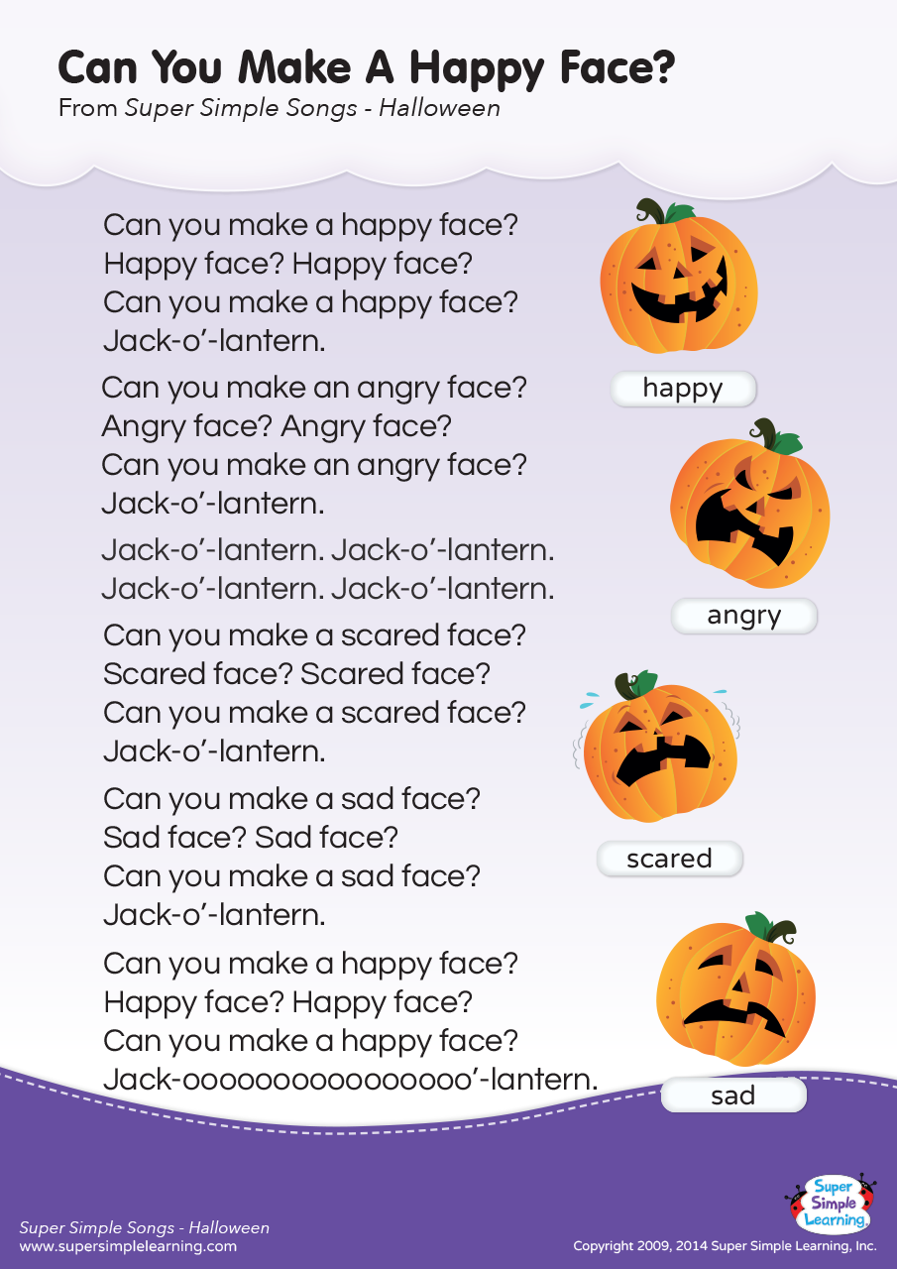[](https://www.google.com/url?sa=i&url=https%3A%2F%2Fwww.freepik.com%2Ffree-vector%2Fbaby-shower-circular-card-with-bear-teddy-baby-cart_4939276.htm&psig=AOvVaw10pQ3eUpnQeYDOF0VUWGxP&ust=1633536216154000&source=images&cd=vfe&ved=0CAYQjRxqFwoTCKDV6PDgs_MCFQAAAAAdAAAAABAD)

Mark your calendars:  
  
Center CLOSED – October 11  
HAPPY COLUMBUS DAY!  
  
  
Spooky Family Fun Night - October 14   
6:00-7:00 – Come dressed in your costume and take a stroll through our (not so spooky 😊 ) spooky walk!  
  
Picture Day – October 21  
*If this is not your child’s scheduled day and you’d like for your child to be in our class picture and/or to have a picture taken please let me know…

**Reminders:**

* Please make sure your child has one or two weather appropriate changes of clothing in his/her bag. Accidents happen and sometimes we like to get messy 😊
* As the weather changes, please make sure that your child has appropriate outdoor attire and a pair of shoes every day. I’m hoping we will get lots of time to play outside on the yearling playground! We may also go for walks in the stroller!
* Please label everything that you bring in for your child. Lunch boxes, containers, sheet/blankets, extra clothes, etc. Labeling helps to avoid confusion when there is a different teacher covering the classroom or when children have similar items. Thank you!
* At the beginning of each month, wipes will be due. I ask that you please bring 4 packs for full time kiddos, and 3 pack for part time kiddos. I will let you know when your child is low on diapers.

If you have any questions or concerns, please do not hesitate to reach out to me. You can chat with me at drop off/pick up or call the center around nap time 12:00 – 2:00.   
  
I look forward to continuing to watch my yearling friends learn and grow throughout the month of October!  
   
 * Ms. Ashley

Our Redeemer Child Care Center  
Yearling Newsletter  
October 2021