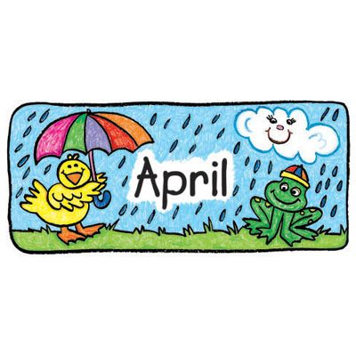
Pre-K News 2021
Our Weekly Themes Birthdays
4/5 - 4/9 ~ April Showers/Weather Llewyn 4/12
Tory 4/13
4/12 – 4/16 ~ I am an Artist
Mark your Calendars
4/19 – 4/23 ~ Earth/Space 4/19 Patriots Day
4/22 Earth Day
4/26- 4/30 ~ Planting/Flowers
Class Reminders…
*Please do some Spring cleaning in your child’s backpack. Make sure that your child has a seasonally appropriate, complete set of extra clothing and at least 2 clean masks each day. Thank you!
*Children must enter the building wearing a mask each day and have 2 clean extra masks.
*Please make sure your child has at least one healthy choice for each meal time. Fruit, veggies, cheese stick, yogurt… 3 healthy choices/day.

Rest Time…
Each week please send 1 sheet, 1 blanket and 2 books. I spy books, look and find etc are great.
1 Coloring or activity book would be great also!! Books your child is interested in and that keep their attention. No board books please! Children can also bring one small plush rest item.

